**ASSIGNMENT 04**

K07 Computer Programming I

**Directions**: Be sure to save an electronic copy of your answer before submitting it to Ashworth College for grading. Unless otherwise stated, answer in complete sentences, and be sure to use correct English, spelling and grammar.

**Radio GUI**

Create the GUI for the radio as shown in Fig. 2.40 below. [Note: The image used in this exercise is located in the examples folder for Chapter 2.]

1. **Manipulating the Form’s properties**. Change the Font property to 9pt Segoe UI. Change the Form’s Text property to Radio and the Size to 427, 194.

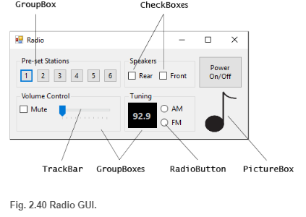

1. Adding the **Pre-set Stations** GroupBox and Buttons. Set the GroupBox’s Size to 180, 55 and its Text to Pre-set Stations. Add six Buttons to the GroupBox. Set each one’s Size to 23, 23. Change the Buttons’ Text properties to 1, 2, 3, 4, 5, 6, respectively.
2. Adding the **Speakers** GroupBox and CheckBoxes. Set the GroupBox’s Size to 120, 55 and its Text to Speakers. Add two CheckBoxes to the GroupBox. Set the Text properties for the CheckBoxes to Rear and Front.
3. Adding the **Power On/Off** Button. Add a Button to the Form. Set its Text to Power On/Off and its Size to 75, 55.
4. Adding the **Volume Control** GroupBox, the **Mute** CheckBox and the **Volume** TrackBar. Add a GroupBox to the Form. Set its Text to Volume Control and its Size to 180, 70. Add a CheckBox to the GroupBox. Set its Text to Mute. Add a TrackBar to the GroupBox.
5. Adding the **Tuning** GroupBox, the radio station Label and the **AM/FM** RadioButtons. Add a GroupBox to the Form. Set its Text to Tuning and its Size to 120, 70. Add a Label to the GroupBox. Set its AutoSize to False, its Size to 50, 44, its BackColor to Black, its ForeColor to Silver, its font to 12pt bold and its TextAlign to MiddleCenter. Set its Text to 92.9. Place the Label as shown in the figure. Add two RadioButtons to the GroupBox. Set the Text of one to AM and of the other to FM.
6. Adding the image. Add a PictureBox to the Form. Set its SizeMode to StretchImage and its Size to 55, 70. Set the Image property to MusicNote.gif (located in the examples folder for Chapter 2).

**Grading Rubric**

*Please refer to the rubric on the next page for the grading criteria for this assignment.*

